**Objectives**

* Identify various life cycle hook methods
* List the sequence of steps in rendering a component

In this hands-on lab, you will learn how to:

* Implement componentDidMount() hook
* Implementing componentDidCatch() life cycle hook.

**Prerequisites**

The following is required to complete this hands-on lab:

* Node.js
* NPM
* Visual Studio Code

**Notes**

Estimated time to complete this lab: **60 minutes.**

1. Create a new react application using *create-react-app* tool with the name as “blogapp”
2. Open the application using VS Code
3. Create a new file named as **Post.js** in **src folder** with following properties

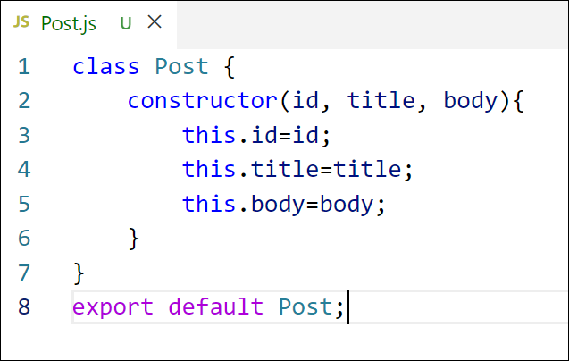

*Figure 2: Post class*

1. Create a new class based component named as **Posts** inside **Posts.js** file

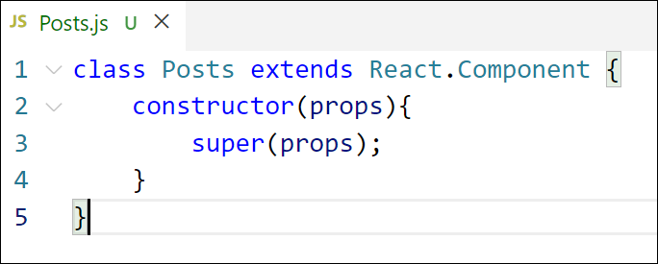

*Figure 3: Posts Component*

1. Initialize the component with a list of Post in state of the component using the constructor
2. Create a new method in component with the name as **loadPosts()** which will be responsible for using Fetch API and assign it to the component state created earlier. To get the posts use the url (<https://jsonplaceholder.typicode.com/posts>)

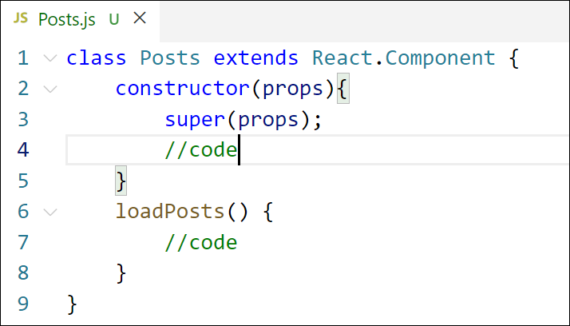

*Figure 4: loadPosts() method*

1. Implement the **componentDidMount()** hook to make calls to **loadPosts()** which will fetch the posts

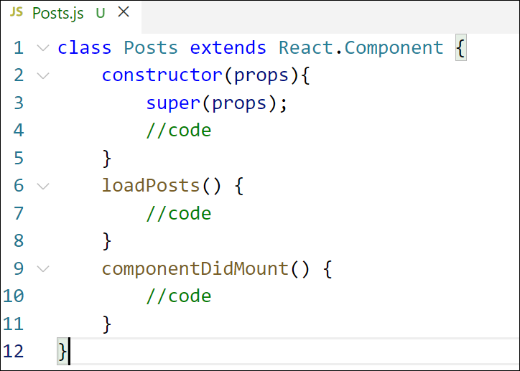

*Figure 5: componentDidMount() hook*

1. Implement the **render()** which will display the title and post of posts in html page using heading and paragraphs respectively.

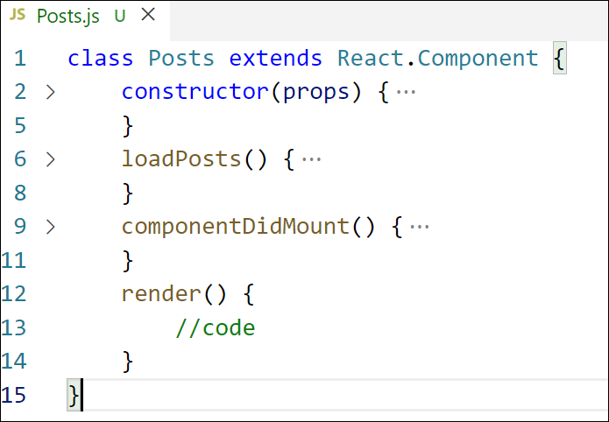

*Figure 6: render() method*

1. Define a **componentDidCatch()** method which will be responsible for displaying any error happing in the component as alert messages.

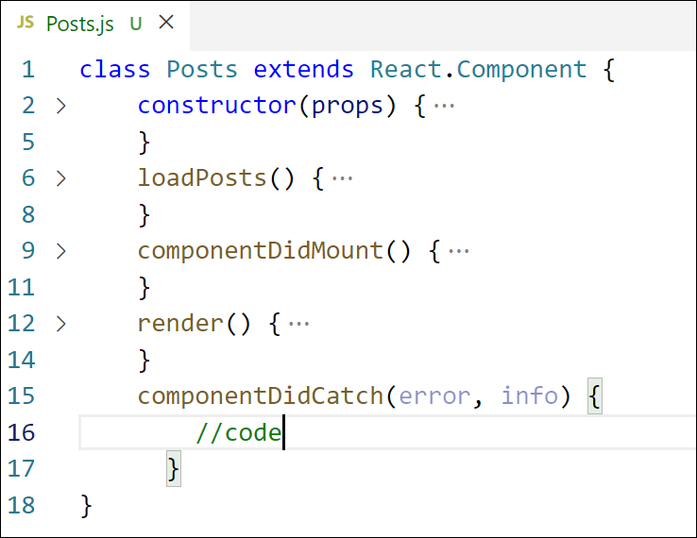

*Figure 7: componentDidCatch() hook*

1. Add the Posts component to App component.
2. Build and Run the application using *npm start* command.

**Create a New React Application**

**Create the Post.js File**

In the src folder, create a new file named Post.js and add the following code:

class Post {

constructor(id, title, body) {

this.id = id;

this.title = title;

this.body = body;

}

}

export default Post;

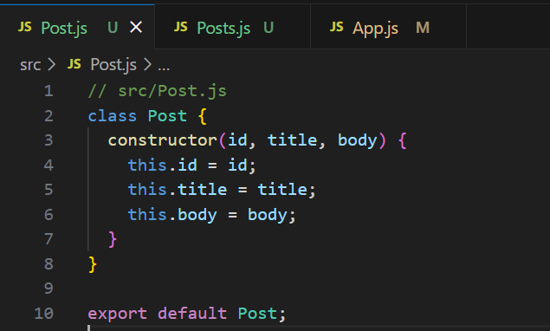**Create the Posts Component**

In the src folder, create another file named Posts.js and create a class-based component:

import React, { Component } from 'react';

import Post from './Post';

class Posts extends Component {

  constructor(props) {

    super(props);

    this.state = {

      posts: [],

      error: null

    };

  }

  loadPosts = async () => {

    try {

      const response = await fetch('https://jsonplaceholder.typicode.com/posts');

      const data = await response.json();

      const posts = data.map(p => new Post(p.id, p.title, p.body));

      this.setState({ posts });

    } catch (error) {

      this.setState({ error });

    }

  }

  componentDidMount() {

    this.loadPosts();

  }

  componentDidCatch(error, info) {

    alert("Something went wrong: " + error.toString());

  }

  render() {

    return (

      <div>

        <h1>All Posts</h1>

        {this.state.posts.map(post => (

          <div key={post.id}>

            <h3>{post.title}</h3>

            <p>{post.body}</p>

          </div>

        ))}

      </div>

    );

  }

}

export default Posts;

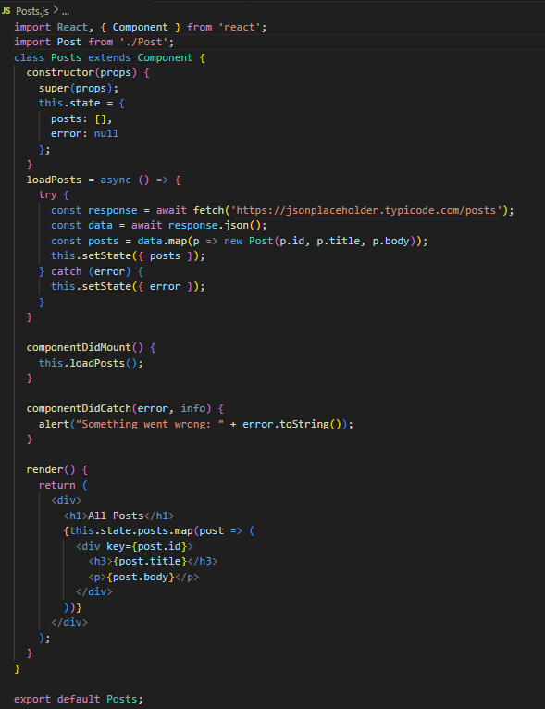

**App.js**

import React from 'react';

import './App.css';

import Posts from './Posts';

function App() {

return (

<div className="App">

<Posts />

</div>

);

}

export default App;

**Run the Application:**

npm start

**OUTPUT:**

